**Lot Quality Assurance Sampling (LQAS)**

hypothesis testing is more nuanced that involves calculating precise prevalence estimates and confidence intervals, testing whether a particular prevalence or something more extreme is probable or not

LQAS is a classification method that answers a yes/no question of whether a lot’s prevalence is meeting a set threshold value or not

priority is getting the extremes really well-classified, okay with units between $p_{l}$ and $p_{u}$ not being correctly classified

α and β error levels are how often you’re okay with making mistakes at either extremes

Benefits

answering a simple question so reduced sample size

simple classification rules that require little statistical training to implement

classifications are very actionable and can lead directly to program management decisions

often used in decentralized data collection and program management

helps understand local variation because done on a very small geographic scale

can be aggregate data from LQAS to get local and regional estimates and be part of complex sampling technique for national population prevalence

**Two-Way Classification**

Step 1 Randomly select $n$ individuals in an area

Step 2 Count the number $x$ that has trait of interest

Step 3 compare $x$ to decision rule, $d$ and classify a lot in low or high category

if $x<d$, lot is in low category

if $x≥d$, lot is in high category

Determining Decision Rule

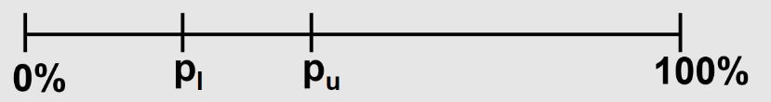

β-error = probability of classifying as high when it’s actually low

α-error = probability of classifying as low when it’s actually high

$p_{u}$ = upper limit proportion

less than $α$ of being classified in the upper category

at least $1-α$ chance to be classified in the lower category

$p_{l}$ = lower limit proportion

less than $β$ of being classified in the upper category

at least $1-β$ chance to be classified in the lower category

search through a large range of sample sizes to find the $n$ and $d$ that satisfy the constraints using binomial distribution to calculate probabilities

for a given $n$, determine if there is a single value $d$ that satisfies both $p_{u}$ and $p_{l}$ with given α and β error levels

once $n≥100$, LQAS becomes similar to complex sampling

increase accuracy of classification with smaller α and β error levels by increasing sample size

decrease distance between categories with tighter $p_{l}$ and $p_{u}$ range by increasing sample size

Example Decision Rule

$$n=19, d=9$$

If less than 9 out of 19 students per class are wearing pink, that class is classified in the low category. If 9 or more students per class are wearing pink, that class is classified in the high category.

$$p_{u}=60\%, α=0.10$$

At 60% pink outfits, we want at least 90% probability of that class being classified in the upper category and less than 10% probability of that class being classified in the lower category.

$$p_{l}=30\%, β=0.10$$

At 30% pink outfits, we want at least 90% probability of that class being classified in the lower category and less than 10% probability of that class being classified in the upper category.

